**DATA ANALYTICS**

**SQL MINI PROJECT**

**INSIGHTS & SQL QUERIES WITH OUTPUT**

**Insight No.1**

**-- 1. Find the average selling price of cars in the dataset.**

**SELECT AVG(selling price) AS average selling price**

**FROM cars. car dataset;**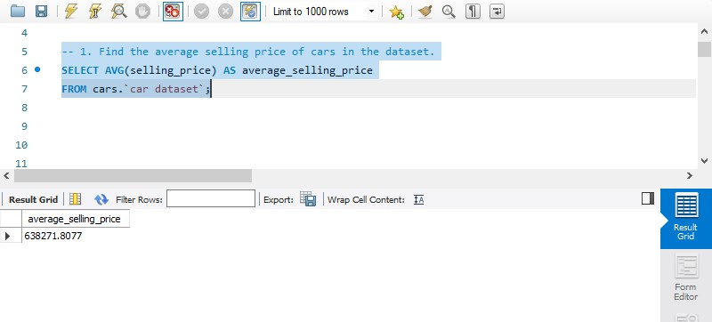

**Insight No.2**

**Identify the most common fuel type used among the cars.**

**SELECT fuel, COUNT(*) AS count from cars car dataset GROUP BY fuel ORDER BY count DESC LIMIT 1;**

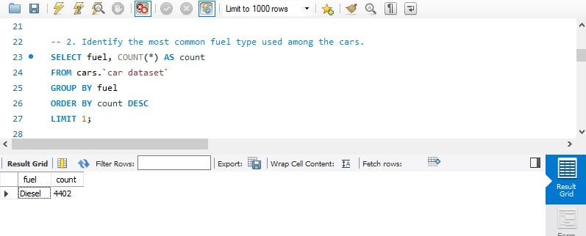

**Insight 3**

**Calculate the average mileage of cars.**

**SELECT AVG(mileage) AS average mileage FROM cars. car dataset;**

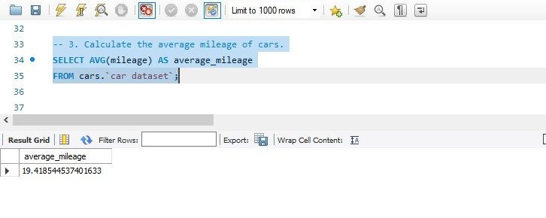

**Insight 4**

**Determine the average kilometers driven per year for each car.**

**SELECT name, (km driven / (2024 - year)) AS avg kms per year FROM cars car dataset`;**

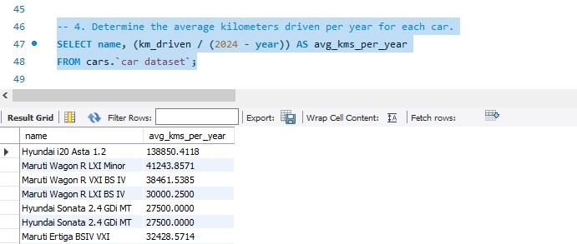

**Insight 5**

**Identify the top 5 car models with the highest selling prices.**

**SELECT name, selling price FROM cars car dataset ORDER BY selling price DESC LIMIT 5;**

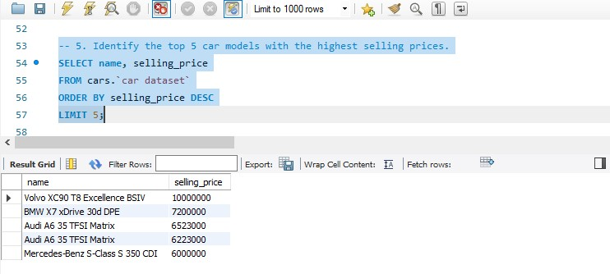

**Insight 6**

**Calculate the percentage of cars with automatic transmission.**

**SELECT (SUM(transmission = 'automatic') / COUNT(*)) * 100 AS automatic transmission percentage FROM cars;**

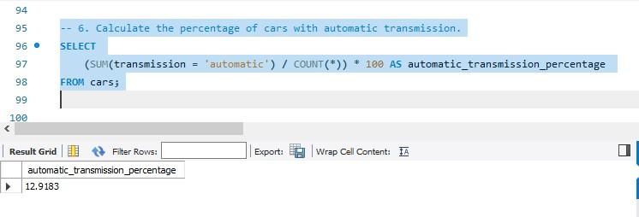

**Insight 7**

**Find the distribution of seller types.**

**SELECT seller type, COUNT(*) AS count from cars. car dataset GROUP BY seller type;**

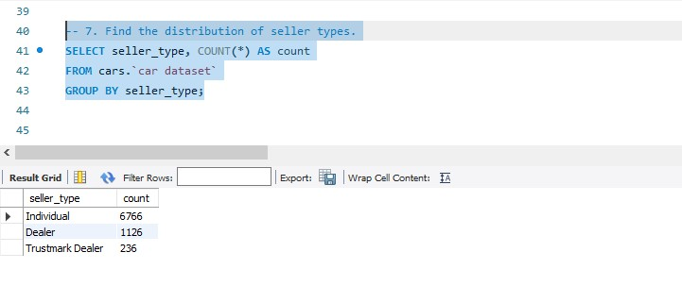

**Insight 8**

**Find the top 5 car models with the highest average mileage among cars manufactured after 2015.**

**SELECT name, AVG(mileage) AS average mileage FROM cars. car dataset WHERE year > 2015 GROUP BY name ORDER BY average mileage DESC LIMIT 5;**

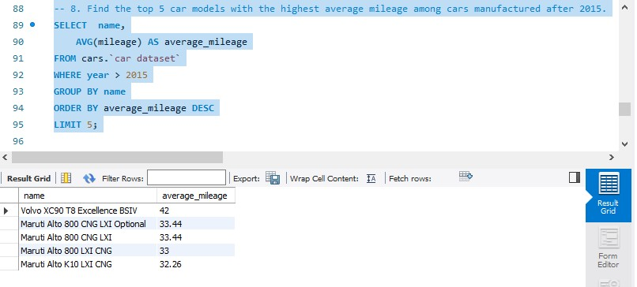

**Insight 9**

**Find the average selling price of cars grouped by fuel type and transmission type.**

**SELECT fuel, transmission AVG(selling price) AS average selling price FROM cars car dataset GROUP BY fuel, transmission;**

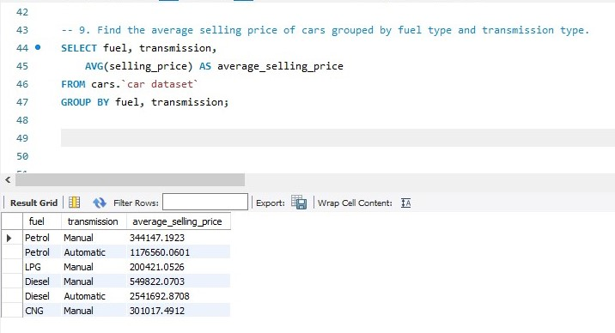

**Insight 10**

**Determine the average selling price for cars with different numbers of owners**

**SELECT owner, (SELECT AVG(selling price) FROM cars car dataset` WHERE owner = outer query owner) AS average selling price FROM (SELECT DISTINCT owner FROM cars car dataset`) AS outer query;**

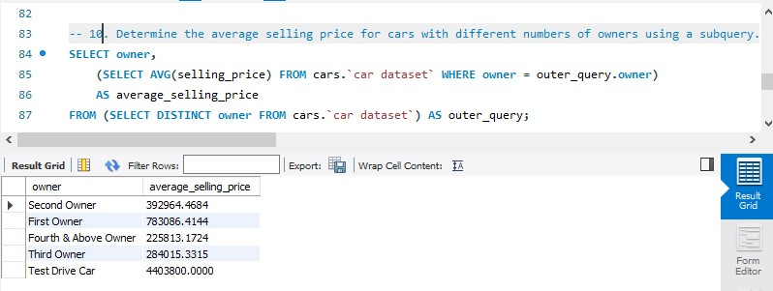

**********END*********